Directions: Write the equations of the lines in both slope-intercept and standard forms.

$m=−2$ and goes through (-3, 4) $m=\frac{5}{2}$ and $b=3$ $m=\frac{1}{3}$ and goes through (-6, 2)

______________________ ______________________ ______________________
(Slope-Intercept Form) (Slope-Intercept Form) ( Slope-Intercept Form)

______________________ ______________________ ______________________
(Standard Form) (Standard Form) (Standard Form)

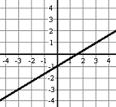 $m=−\frac{3}{4}$ and goes through (8, -3) 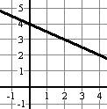

______________________ ______________________ ______________________
(Slope-Intercept Form) (Slope-Intercept Form) ( Slope-Intercept Form)

______________________ ______________________ ______________________
(Standard Form) (Standard Form) (Standard Form)

